EXPERIMENT 4
Execute and display the results for the following commands in Kali Linux Operating Systems:
ls command
cat command
mkdir command
AIM : To execute and study the ls, cat, and mkdir commands in Kali Linux and observe their results.
DESCRIPTIONS
1. ls Command : The ls command is used to list the files and directories present in the current directory.
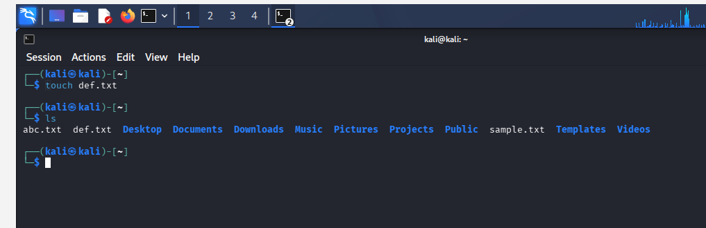
2. cat Command : The cat command is used to display the contents of a text file. It can also be used to create and combine files.
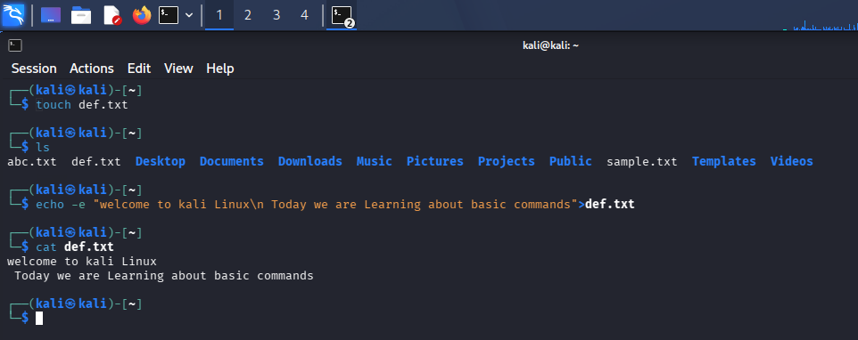
3. mkdir Command : The mkdir command means "make directory". It is used to create a new directory (folder) in Linux.
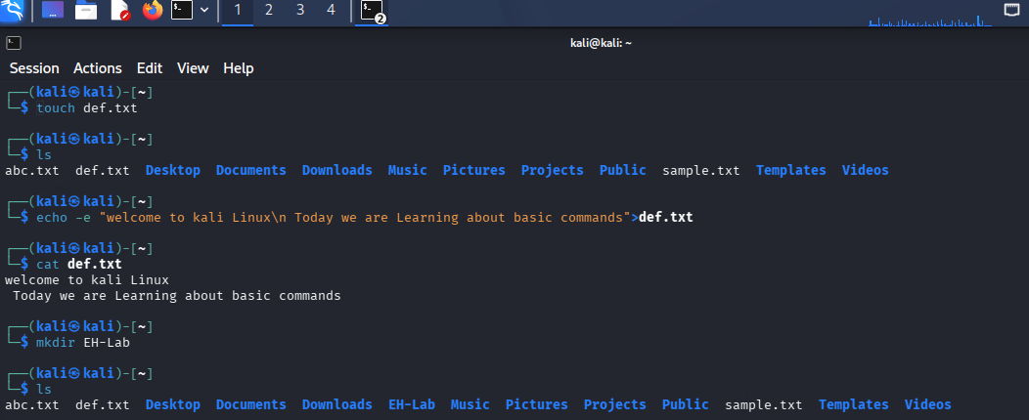
RESULT : The ls, cat, and mkdir commands were successfully executed in Kali Linux. The ls command displayed directory contents, cat displayed the contents of a text file, and mkdir created a new directory.

